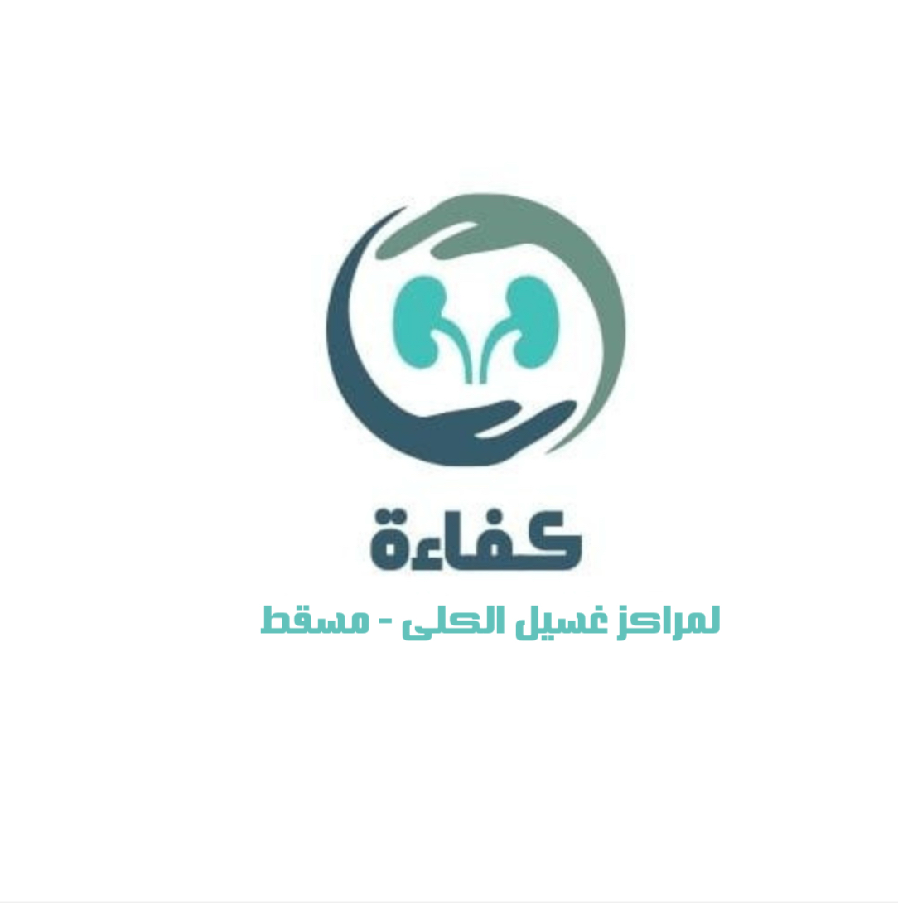


"kafa’a" Initiative for Evaluating the Performance of
Dialysis Centers in Muscat Governorate
مبادرة "كفاءة" لتقييم أداء مراكز غسيل الكلى في محافظة مسقط

Section 1: General Information
Item | Details
Dialysis Unit Name:
Location:
Total number of registered patients:
Total number of dialysis beds:
Date of Evaluation:
Evaluator’s Name:

Table 1: Institutional Evaluation Form
The evaluation will be done for last 6 months for 30 criteria which will audited either via observation on spot, interview or available documents.
Serial  No | Criteria |  | Met  (3) | Partially Met  (2) |  | Not  Met (1) | Remarks
Section 2: Leadership & Governance
2.1 | Nurses to patient’s ratio is 1:3 as per assignment sheet, assess randomly in the last 6 months  ( 10 days ) |  | 90% | 80% |  | 70%
2.2 | Staff aware about the approved guidelines and policy in Al Shifaa as compliance check list every 3 months |  | 90% | 80% |  | 70%
2.3 | Check for Evidence of scheduled monthly departmental meetings concerning practice & improvement plan |  | 4 | 3 |  | 2
2.4 | Achievements in clinical practice or quality improvement objectives-check record |  | 3 | 2 |  | 1
2.5 | Nurses had been evaluated on code of professional conduct- check record |  | 100% | 80% |  | 60%
2.6 | Staff properly document dialysis procedures, Audit 10 staff for proper documentation |  | 80% | 70% |  | 60
2.7 | NCR with improvement action plan available for Internal Audit-check documents |  | 100% | 80% |  | 70%
2.8 | NCR with improvement action plan available for external & peer audits-check documents |  | 100% | 80% |  | 70%
2.9 | List of staff attend scheduled staff development activities (CPD) -check documents |  | 80% | 70% |  | 60%
2.10 | List of Staff performance policy and nephrology procedure KPIs is conducted every 3 months |  | 80% | 70% |  | 60%
2.11 | List of staff certified in IV therapy |  | 80% | 70% |  | 60%
2.12 | List of staff hold valid BLS certification |  | 80% | 70% |  | 60%
2.13 | List of doctors certified in ACLS |  | 90% | 80% |  | 70%
2.14 | Community renal health awareness sessions conducted per last 6 |  | 2 | 1 |  | 0
2.15 | Risk register maintained with all risks reviewed and reported every 3 months |  | 90% | 80% |  | 70%
2.16 | Aman system managed with RCA and action plan |  | 90% | 80% |  | 70%
Section 3: Facility & Hemodialysis Equipment
3.1 | All machines calibrated and PPM completed as scheduled via biomedical tech. | 100% |  | 90% | 80%
3.2 | Monthly lab reports as IPC for water testing are up to date | 100% |  | 90% | 80%
3.3 | Report received about Regular tank cleaning documented; no lapses >1 month | Less  1 M |  | 2 M | 3 M
3.4 | Audit Infectious patients with HBsAg & HCV (properly isolated observation ,diary, per infection control) | 100% |  | 90% | 80%
Section 4: Protocol of Clinical Care
4.1 | Individual treatment plan documented and updated for each patient- assess randomly for 10 patients | 100% |  | 90% | 80%
4.2 | Patient assessment completed before every dialysis session- assess randomly for 10 patients | 100% |  | 90% | 80%
4.3 | Vital signs documented during each session- assess randomly for 10 patients | 3 |  | 2 | 1
Section 5: Patient Satisfaction
5.1 | patient satisfaction based on latest survey | 90% |  | 80% | 70%
5.2 | Corrective Action Plan available for each complaint cycle based on latest survey of patient satisfaction | 90% |  | 80% | 70%
Section 6: Emergency Preparedness
6.1 | Two equipped crash carts report available, regularly checked at each shift and updated, assess randomly for 10 days | 100% |  | 90% | 80%
6.2 | Written, site-specific emergency and evacuation plan is available and known to staff, interview randomly 10 staff | 100% |  | 90% | 80%
6.3 | Staff are trained in evacuation plan, check register and interview randomly 10 staff | 90% |  | 80% | 70%
6.4 | Nurses trained in emergency & Crush cart with documentation, check register | 90% |  | 80% | 70%
6.5 | Emergency drills are conducted within the institution in the last 6 months | 2 |  | 1 | 0

Table 2. Clinical care and follow up
The evaluation will be done for last 6 months for 36 criteria which will audited either via observation on spot, interview or available document.
Serial  No | Criteria | Met (3) | Partially Met (2) | Not  Met (1) | Remarks
Section 1. Laboratory Targets

1.1 | Achieved Hemoglobin level 10 g/dL or more. | >80% | 79-70 % | <70% |  | Cases with hb improved with + 1g over last month not to be calculated as new cases bias, or patients achieve guidelines of anemia treatment.
1.2 | Keep calcium within normal level 2.1–2.6 mmol/L. | >85% | 84-75% | <75% |  | Same exclude as per guidelines
1.3 | Keep iPTH (pmol/L) level 2-9 times the upper limit. | >75% | 74-70% | < 70%
1.4 | Keep Serum Albumin (g/L) ≥35 g/L that reflects protein energy wasting to some extent. | >75% | 74-70% | < 70%
1.5 | Achieved Kt/V ≥ 1.2 for total patients as per monthly statistical report | >70% | 70-60% | <60%
1.6 | Achieved URR ≥ 65% for total patients as per monthly statistical report | >65 | 65-60% | <60%
1.7 | Keep Transferrin saturation (%) ≥20% | >75% | 74-70% | < 70%
Section 2. Clinical Outcomes

2.1 | Achieved Hospitalization rate < 2 admission per patient per year, for patient with IV access infection (a random sample of 10 patients or records) | < 2 | 3-4 | >4
2.2 | Achieved Mortality rate < 15% annual | < 15% | 15-19% | > 20%
2.3 | Dry weight achievement (a random sample of 10 patients) | >70% | 69-60% | <60%
2.4 | Evaluation of the routine clinical assessment during clinical rounds Evaluated through doctor and nurse notes (a random sample of 10 patients) | >95% | 94%-80% | < 80%
Section 3. Vascular Access
3.1 | No of Hemodialysis central venous Catheter (CVC) use- check records | <30% | 30% - 40% | >40%
3.2 | Achievement of Catheter infection rate per 1000 session- check records | <1.5 | 1.5-1.7 | >1.7
3.3 | Number of doctors trained in Access flow monitoring | 3 | 2 | 1 |  | No need , as goal checked in next point
3.4 | Access flow monitoring of total patients at least once annually by POCUS , check records or random sample of 10 patients. | >60% | 59-50% | <50%
3.5 | No of AVF and AVG from total patient, check records | > 70% | 69-60% | <60%
Section 4. Quality of Care
4.1 | Treatment time adequacy ≥3.5 hrs/session, 3x/week (a random sample of 20 patients) | >80% | 79%- 70% | < 70%
4.2 | Missed/shortened sessions, check record | >10% | 10-12% | <13
4.3 | Available document of Monthly Multidisciplinary rounds | 4 | 3 | 2
Section 5. Infection Prevention& Control

5.1 | Infection control audit (according the standards of IPC)  Refer to the infection control policy of DGHS Muscat and related resources. | >95% | 94%- 85% | <85%
5.2 | HCWs demonstrate competency in hand hygiene technique, (check competency list of 10 staff) | >95% | 94%- 85% | <85%
5.3 | HCWs received training and demonstrate competency on proper use of PPE, (check competency list of 10 staff) | >95% | 94%- 85% | <85%
5.4 | Evidence record of staff and patients screening and immunization completion as per IPC audit | >90% | 89%- 80% | <80%
5.5 | Evidence of Implemented and recorded Surveillance in Dialysis Unit include Dialysis events and CLABSI bundle (for patients with central line catheter) check the last 3 patients prior the evaluation period. | Complete for the 3 patients | Partial for the 3 patients | Not done
Section 6. Patient Management

6.1 | Available document of Patient education sessions or events as per plan and executed | 3 | 2 | 1
6.2 | Updated Individual care plans quarterly ( select a random sample of 10 patients more than 6 months on same center) | 2 plans | 1 plans | 0 plan
6.3 | Updated Nutrition assessment quarterly ( select a random sample of 10 patients more than 6 months on same center ) | 2 assessments | 1 assessment | 0 assessment
Section 7. Governance & Documentation
7.1 | Revised nephrology Guidelines & protocols and Aligned with KDIGO/KDOQI | present and Aligned | present and not Aligned | no clear Guidelines
7.2 | Documented Evidence of Quality improvement programs | 2 | 1 | 0
7.3 | Documented Evidence of Mortality review in the last 6 months | 2 Documents | 1 Document | 0 Document |  | Explain what is needed

Table 3. Equipment availability and proper utilization (other than dialysis machines):
Serial  No | Criteria | Met (3) | Partially Met (2) | Not  Met (1) | Remarks
Section 1. Ultra-sonography and Doppler for Better clinical and vascular access evaluation

1.1 | Assess 2 doctors for Doppler evaluation of vascular access, as per pocus audit tool | Fully Achieved | Partially Achieved | Not Achieved
Section 2. ECG
2.1 | Cardiac assessment of 10 cardiac patients for ECG done and recorded and management plan is satisfactory. | Fully Achieved | Partially Achieved | Not Achieved
Section 3. Oxygen and suction Airway care and management of hypoxia

3.1 | Interview 3 staff for Management of hypoxia and maintain airway clearness and knowledge of different airway tubes. | 3 Achieved | 2 Achieved | 1 Achieved
Section 4. Defibrillator use in emergency situations, including cardiac arrest and arrhythmias

4.1 | Interview 3 staff with ACLS for Appropriate procedure and steps, adjustment of voltage and safety of use. | 3 Achieved | 2 Achieved | 1 Achieved

During evaluation of the above-mentioned equipment, the following objectives have to be put into consideration:
- Availability, functionality, and safe use of the equipment.
- Ensure that staff are trained and competent in using each item.
- Monitor adherence to maintenance and calibration schedules.
- Evaluate emergency preparedness and patient safety measures.

Table 4. Documentation and registration:
Serial  No | Criteria | Met (3) | Partially Met (2) | Not  Met (1) | Remarks
Section 1. Initial Assessment Documentation
1.1 | Full nephrologist documented evaluation for new patients: history, comorbidities, HD plan, vascular access, and modality discussion ( a random sample of 10 patients ) | 100% | 90% | 80%
Section 2. Monthly Progress Notes
2.1 | Evidence of documented nephrologist review each month, covering clinical status, labs, access, medications, and plan ( a random sample of 10 patients ) | 100% | 90% | 80% |  | Repeat
Section 3. Medication and Dialysis Orders
3.1 | Dialysis prescription and medication orders signed, dated, and reviewed regularly ( a random sample of 10 patients ) | 100% | 90% | 80%
Section 4. Multidisciplinary Communication
4.1 | Documentation of interaction with nurses, dietitian, and other team members in patient records. | Consistent & documented | Occasional or limited | No evidence of collaboration
Section 5. Complication and transfer Reporting in al shifa plus
5.1 | Proper documentation and follow-up of adverse events (e.g., hypotension, access issues, hospital transfers), Check 3 events randomly. | 3 Events documented & reviewed satisfactory | 2 Events documented & reviewed satisfactory | 1 Events documented & reviewed satisfactory

Table 5. Pharmacy & Medication
Serial  No | Criteria | Met (3) | Partially Met (2) | Not  Met (1) | Remarks
Section 1. Pharmacy audit
1.1 | Available Evidence of the audit performed by DGHS Muscat Pharmacy team. | 90% | 80% | 70%
1.2 | Audit results calculated by no. of NCR | 0 NCR | 1 NCR | 2 NCR
1.3 | Action plan report done. | 100% | 80% | 70%
1.4 | Educational public activities related to Renal diseases. | 2 | 1 | 1
1.5 | The pharmacists participating in different activities related to dialysis | 2 | 1 | 0

Table 6. Nursing care
Serial  No | Criteria | Met (3) | Partially Met (2) | Not  Met (1) | Remarks
Section 1. Nursing Audit

1.1 | Evidence of the audit report performed by DGHS Nursing team with satisfactory result as per nursing guidelines. | 90% | 80% | 70%
1.2 | Audit results calculated by no. of NCR | 0 NCR | 1 NCR | 2 NCR
1.3 | Action plan report done. | 100% | 80% | 70%
1.4 | Strategic regional plan is aligned with the institutional needs of RDC | Available & strong objectives | Available but not as per need | Available & very weak and general
1.5 | The nurses are participating in different activities related to dialysis settings | 3 nurses | 2 nurses | 1 nurse

Overall Evaluation
Item | Assessment
Overall compliance rate | 79 Items Max x 3 points max / 237 points
Overall score | ☐ Excellent ☐ Very Good ☐ Good ☐ Satisfactory
General Recommendations

Suggested Action Plan

Index: The total combined score for all evaluations is 237 points.

Excellent: above 220
Very Good: 219- 200
Good: 199- 180
Needs improvement: less than 180 points

